Suggestion 1: Keep pagination in center(All pages). **- Fixed**

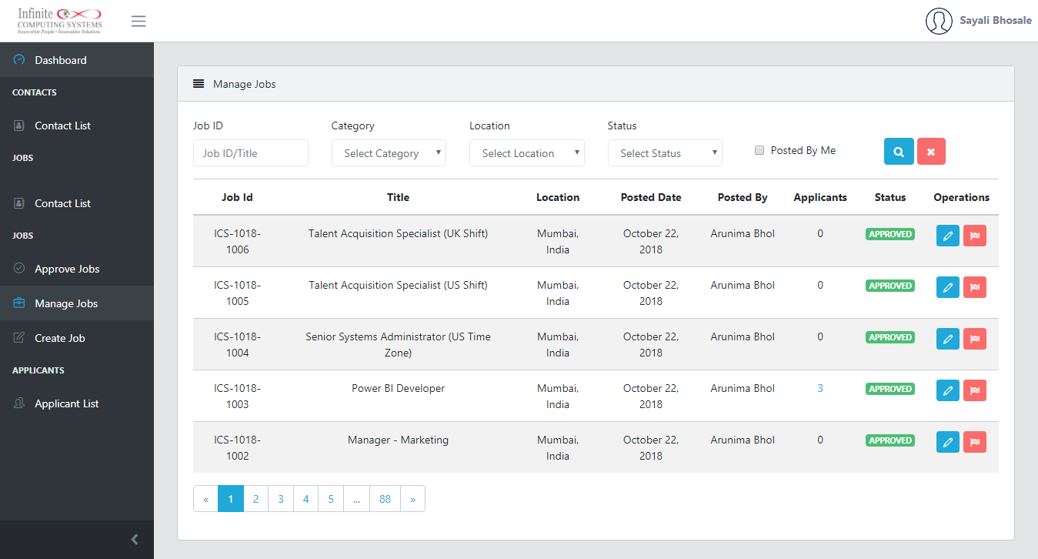

Issue 2: Incorrect records is displayed in ‘Our latest’ job section. **- Fixed**

Steps:

1. Navigate to ‘career’ page.
2. Select ‘Search by category/Search by location/search Jobs’ and click on <Search> button.
3. Ideally based on selection of category records should be displayed in ‘Our latest’ job section.

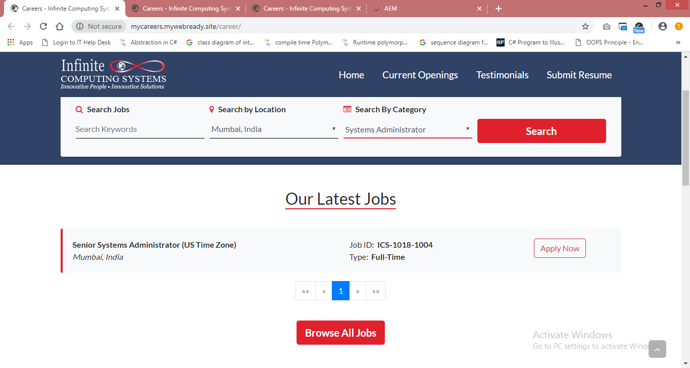

After clicking on <Search> button.

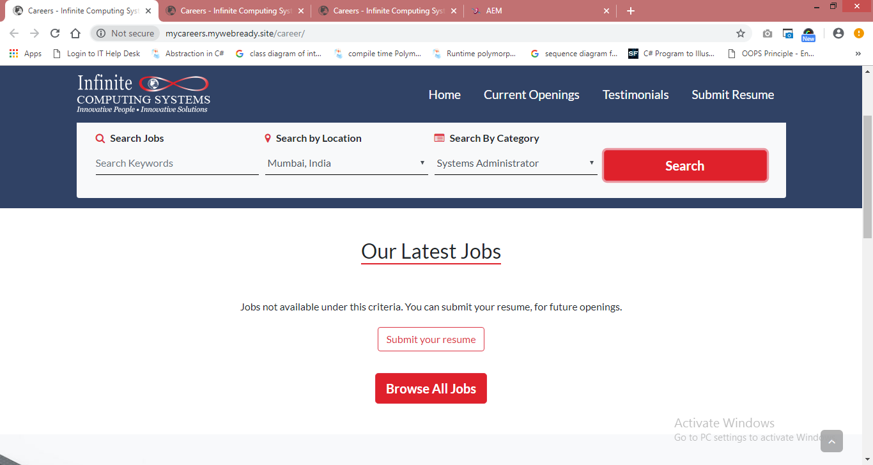

Issue 3: In ‘Our latest Job’ section <Submit your resume> button should not be displayed. **- Fixed**

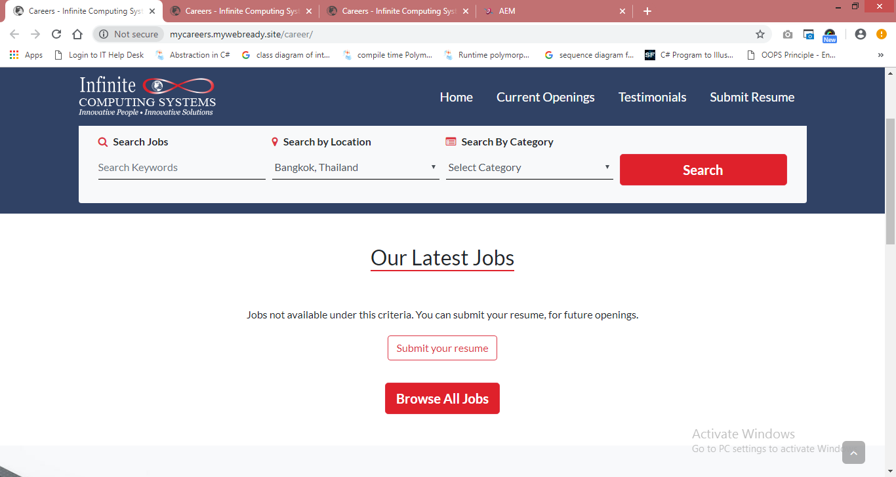

Suggestion 4: Navigation link should be displayed to navigate from ‘All jobs’ to ‘our latest jobs ‘section. **- Fixed**

Suggestion 5: Layout of ‘Create job section’ should be same like ‘manage Jobs’ section. **- Fixed**

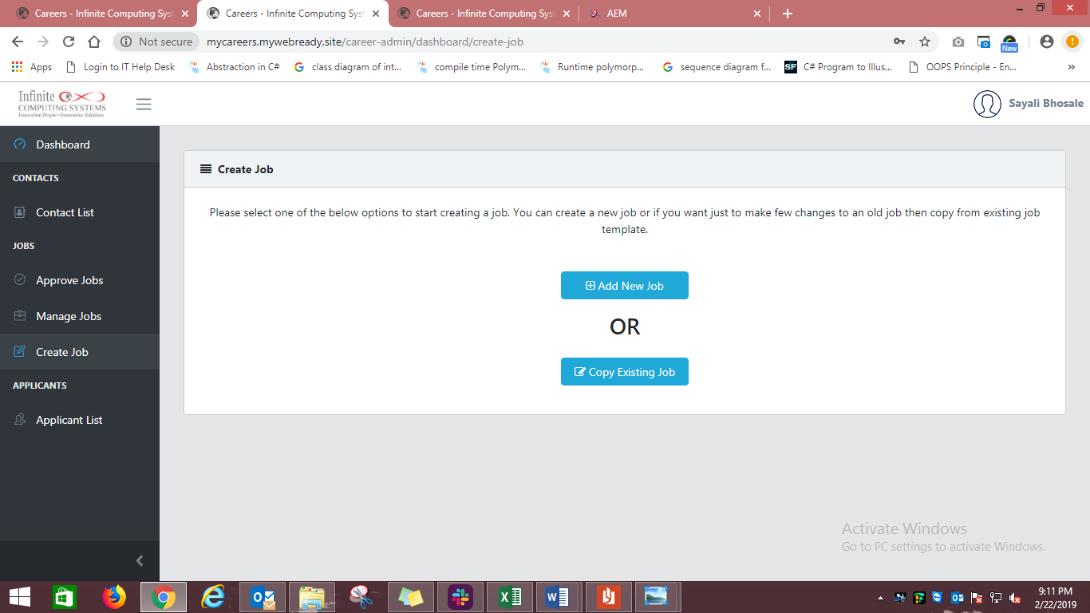

Issue 6: Asterisk symbol is missing (All jobs section/Job details section). **- Fixed**

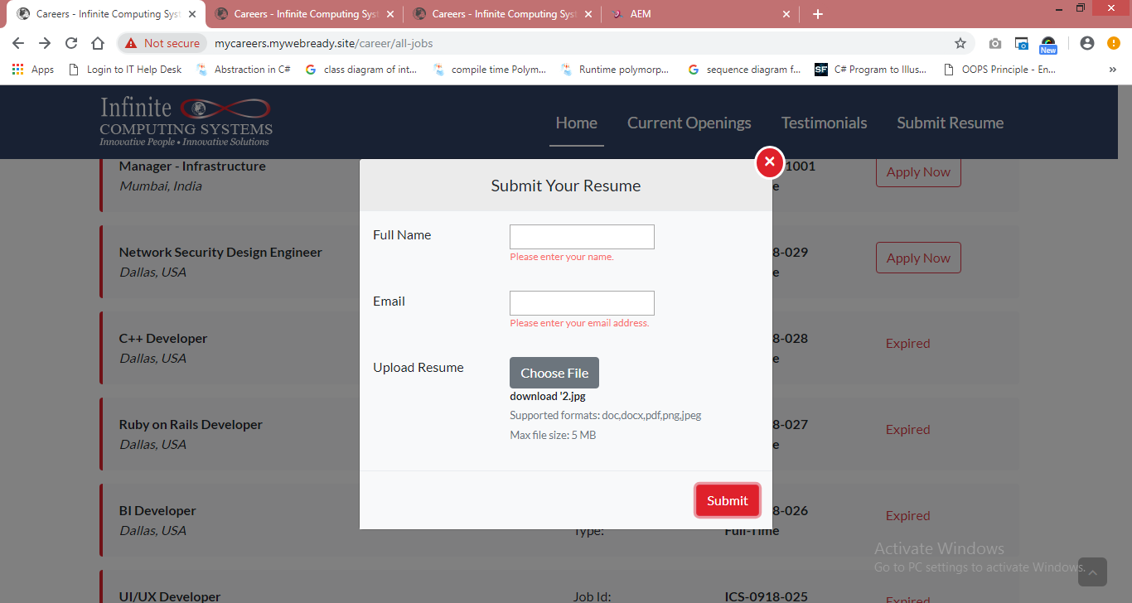

Issue 7: Less space required between fields (All jobs section). **- Fixed**

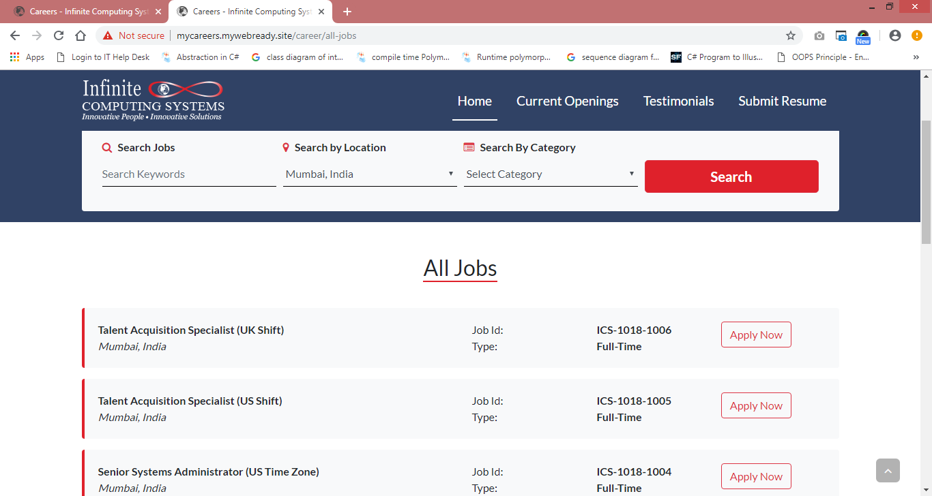

Suggestion 8: In ‘All jobs’ section ‘submit your resume’ button should be displayed at the end of the page. **- Fixed**

Issue 9: Without clicking on <search> button record should not be displayed in ‘Our latest section and all jobs’ section. **- Fixed**

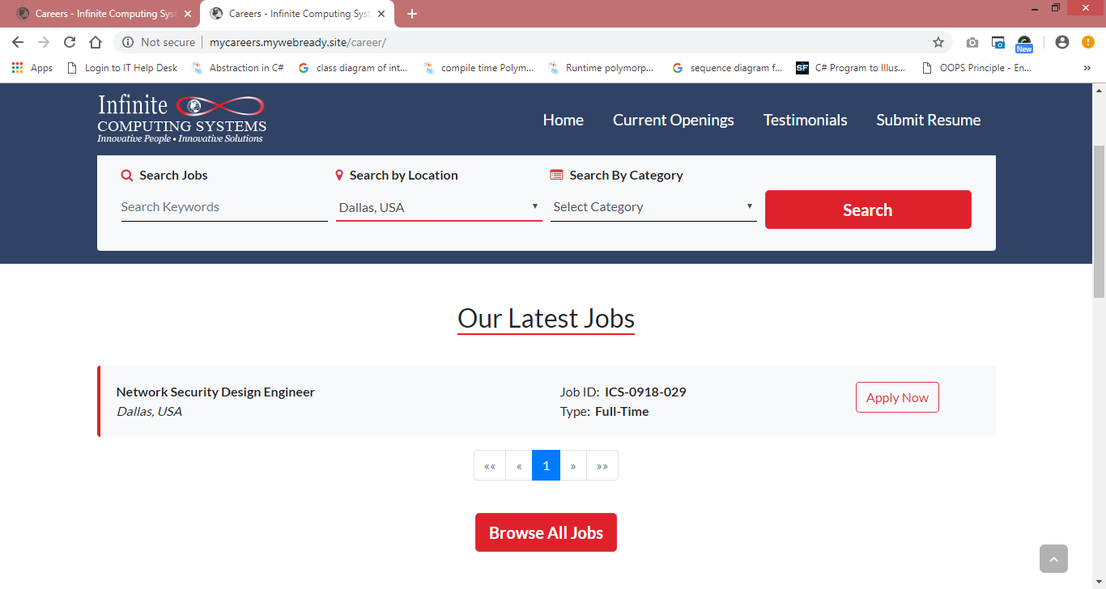

Issue 10: Timeout should not be provided for ‘Already applied’ pop-up. **- Fixed**

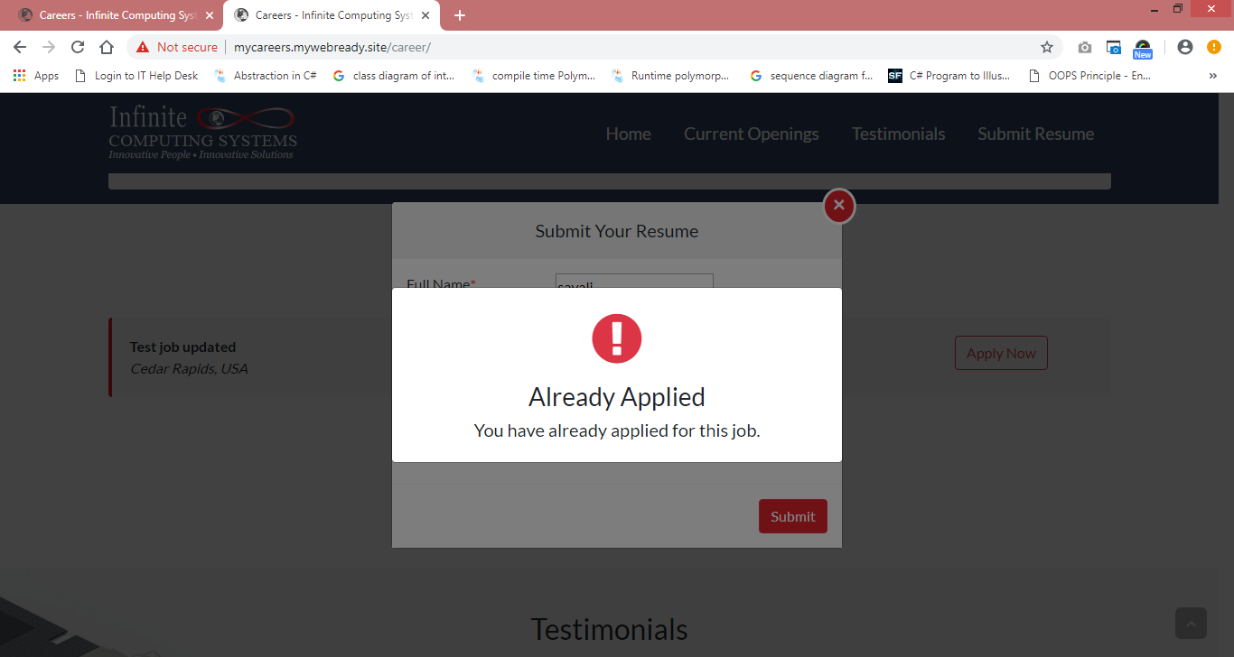

Issue 11: Validation should not be removed when user uploads incorrect file (Applicable for all pages). **- Fixed**

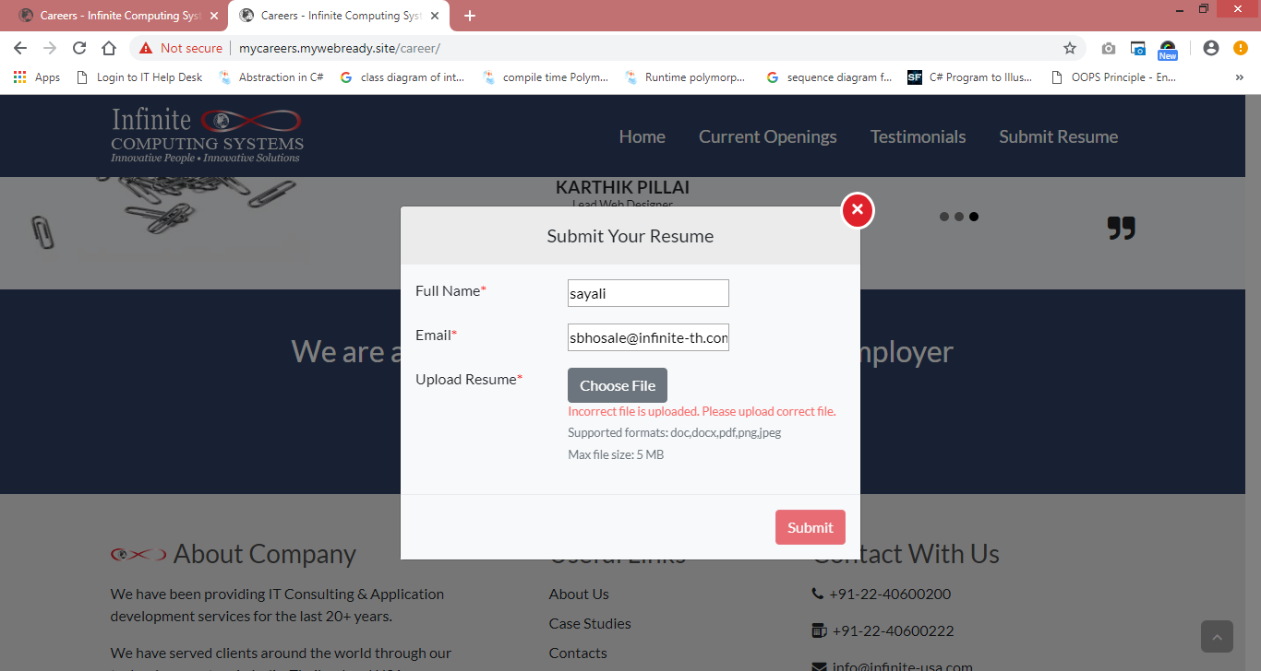

Suggestion 12: When user apply for the same job ‘Already applied’ pop-up should not be closed and when user clicks anywhere on page ‘Submit your resume’ pop-up will be displayed without added previous value. **- Fixed**

Suggestion 13: Provide link to navigate ‘Our latest job’ from ‘All jobs’ section. **- Fixed**

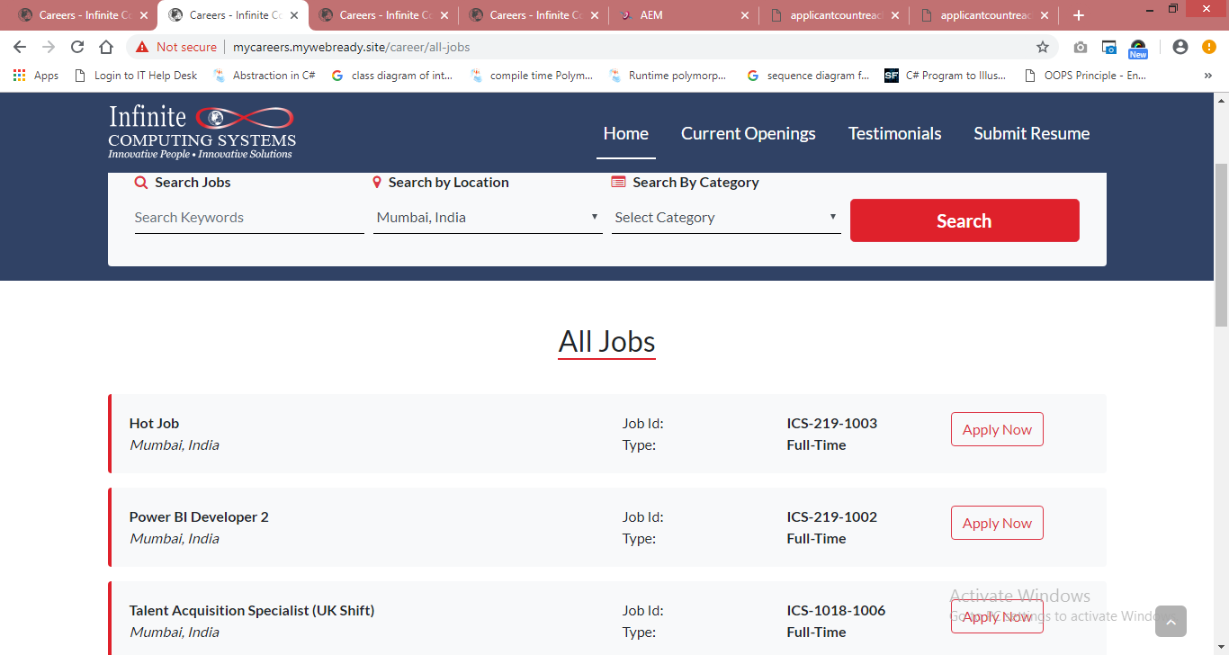

Issue 14: background color is missing for ‘closed’ status. **- Fixed** 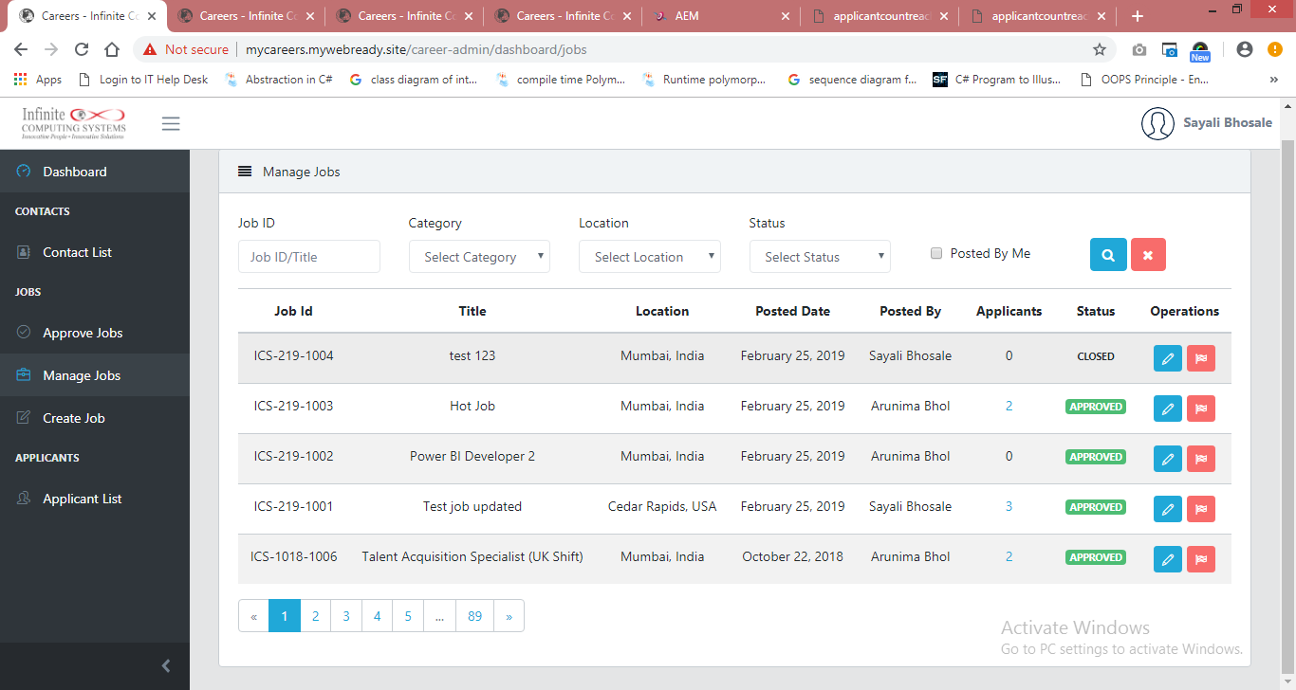

Suggestion 15: On ‘All jobs’ page ‘submit your resume’ button should be displayed. **-FIXED**

